Theme : conflicts in the workspace

Warm up: discussion

What are the different types of conflict that could occur at work? Look for atleast 3 types and elaborate on them.

What techniques can you use to handle conflicts at work?

\*\*Types of Conflict at Work:\*\*

1. \*\*Interpersonal Conflict:\*\*

- \*\*Description:\*\* Interpersonal conflict arises between individuals due to differences in personalities, communication styles, values, or personal preferences. It can manifest as disputes, tension, or misunderstandings between co-workers, managers, or team members.

- \*\*Elaboration:\*\* For example, conflicting work styles or disagreements on project approaches can lead to interpersonal conflict. This type of conflict can hinder collaboration, reduce team morale, and impact overall productivity.

2. \*\*Task-related Conflict:\*\*

- \*\*Description:\*\* Task-related conflict emerges from differences in opinions or approaches related to work tasks, goals, or projects. It often involves disputes over decision-making, resource allocation, or conflicting priorities within the team.

- \*\*Elaboration:\*\* For instance, team members may have varying opinions on the best approach to a project, leading to disagreements on the strategy or allocation of resources. Task-related conflicts can impede progress and hinder the successful completion of projects.

3. \*\*Structural Conflict:\*\*

- \*\*Description:\*\* Structural conflict is rooted in organizational design, policies, or resource distribution. It occurs when there are disparities in roles, responsibilities, or resource availability that create tension among employees or teams.

- \*\*Elaboration:\*\* An example of structural conflict could be disputes over the allocation of budgetary resources among different departments. If one team feels unfairly treated in terms of budget or resource allocation, it can lead to tension and conflicts within the organization.

\*\*Techniques to Handle Conflicts at Work:\*\*

1. \*\*Open Communication:\*\*

- \*\*Description:\*\* Encourage open and honest communication among team members. Create an environment where individuals feel comfortable expressing their concerns, opinions, and viewpoints.

- \*\*Techniques:\*\* Regular team meetings, one-on-one discussions, and feedback sessions can help foster communication. Establishing clear channels for sharing ideas and concerns can prevent conflicts from escalating.

2. \*\*Conflict Resolution Training:\*\*

- \*\*Description:\*\* Provide employees with training in conflict resolution techniques. Equip them with the skills to identify, address, and resolve conflicts in a constructive manner.

- \*\*Techniques:\*\* Training sessions can include role-playing scenarios, communication workshops, and conflict resolution exercises. This helps employees develop the necessary skills to navigate conflicts effectively.

3. \*\*Mediation and Facilitation:\*\*

- \*\*Description:\*\* Introduce a neutral third party, such as a mediator or facilitator, to help manage and resolve conflicts. This can be particularly useful in cases where interpersonal conflicts have escalated, and a neutral perspective is needed.

- \*\*Techniques:\*\* The mediator can guide discussions, help identify common ground, and facilitate the development of solutions. This approach provides an unbiased perspective and can lead to more sustainable resolutions.

In summary, understanding and addressing different types of conflict, combined with effective conflict resolution techniques, can contribute to a healthier work environment and improved team dynamics.

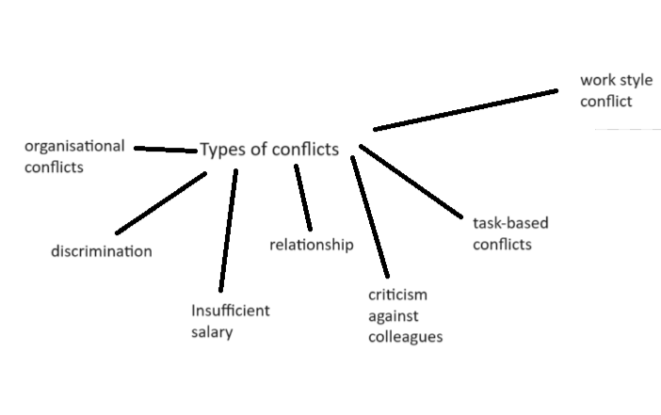

Organisational conflict

1. Inform the employer/authority.
2. Collaborate and compromising (ask for a favour/help)
3. Having plausible arguments (valid, informed)
4. Actively listen and try to understand the other person’s point of view.

Get it off your chest

I completely got the wrong end of the stick

Escalated

Byte my tongue

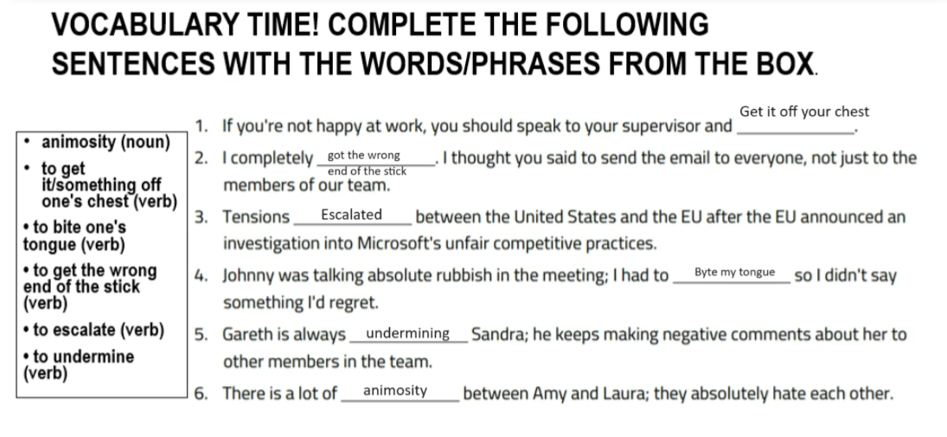

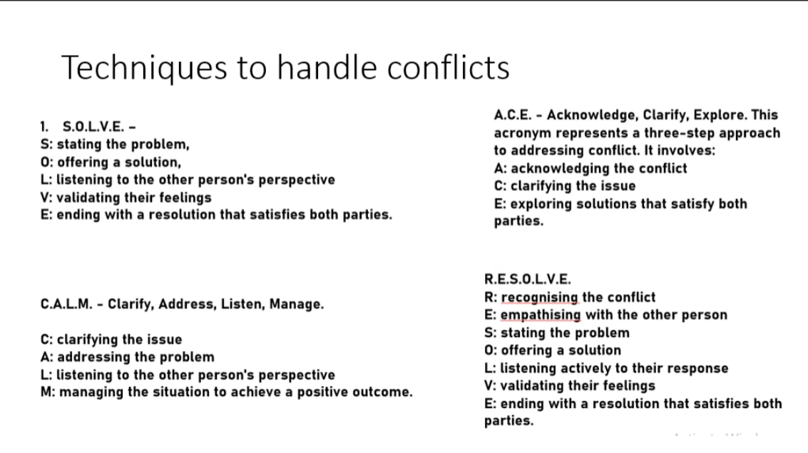

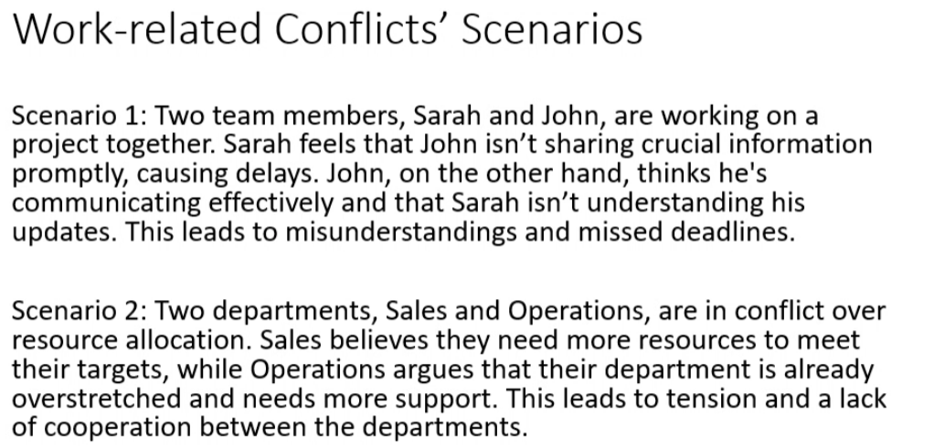

Lack of communication, communication based conflict

\*\*Stating the Problem:\*\*

Sarah: "John, I've noticed that there have been delays in our project, and I believe it's due to a lack of timely information sharing. I feel like I'm not getting the crucial updates I need to proceed with my tasks efficiently."

John: "I understand your concerns, Sarah, but I believe I've been communicating effectively. I'm not sure why there's a perception of delays on my end."

\*\*Offering a Solution:\*\*

Sarah: "To address this issue, can we establish a more structured communication plan? Perhaps a regular check-in meeting or a shared document where we can update each other on project progress and any challenges we're facing?"

John: "That sounds reasonable. I'm open to trying a more structured approach. Maybe we can also clarify the urgency of certain updates so we can prioritize effectively."

\*\*Listening to the Other Person's Perspective:\*\*

Sarah: "I appreciate your willingness to try a new approach. Can you help me understand how you currently perceive our communication? It might help me see things from your perspective."

John: "I believe I've been providing updates as needed, but perhaps my communication style isn't aligning with your expectations. I'm open to adjusting and finding a middle ground."

\*\*Validating Their Feelings:\*\*

Sarah: "I understand that we may have different communication styles, and I acknowledge that my expectations might not have been clear. I value your perspective, and I want us to find a solution that works for both of us."

John: "I appreciate your understanding, Sarah. I also want to make sure we're on the same page and can collaborate more effectively moving forward."

\*\*Ending with a Resolution that Satisfies Both Parties:\*\*

Sarah: "Great. So, let's try implementing the regular check-in meetings and the shared document. This way, we can ensure that we're both informed and can address any concerns promptly. How does that sound?"

John: "Sounds like a plan. I think with these adjustments, we can improve our communication and avoid any future misunderstandings. Let's give it a try and reassess after a few weeks to see how it's working for both of us."

By following this approach, Sarah and John can address their communication issues, find common ground, and work towards a resolution that satisfies both parties. This process emphasizes effective communication, collaboration, and a willingness to adapt for the benefit of the project and their working relationship.

\*\*Stating the Problem:\*\*

Identify the issue: Sarah perceives delays in the project due to what she sees as a lack of timely information sharing from John.

\*\*Offering a Solution:\*\*

Propose a resolution: Sarah suggests implementing a more structured communication plan, such as regular check-in meetings or a shared document for project updates. Clearer informations

\*\*Listening to the Other Person's Perspective:\*\*

Seek understanding: Sarah asks John to share his perspective on their current communication dynamics, aiming to comprehend his point of view.

\*\*Validating Their Feelings:\*\*

Express empathy: Sarah acknowledges the possibility of differing communication styles and clarifies her expectations, showing understanding and respect for John's perspective.

\*\*Ending with a Resolution that Satisfies Both Parties:\*\*

Agree on a plan: Both agree to try the proposed communication plan, incorporating regular check-in meetings and a shared document. They commit to reassessing its effectiveness after a few weeks to ensure mutual satisfaction and project efficiency.

Send an email for further information if Sarah don’t understand.

Ace: Lack of clarity, the information is not clear, send more details,

Scenario 2:

Conflict: resource allocation

Empathy: we understand that your department need supppor, we can offer it (sales)

State the problem: manpower, lacking people, intervene and send people in rush hours, issues, not able to meet their targets (sales is not able to meet the targets), recruit more people instead of just relying on one another for both operations and sales.

Express their feeling: both of them overwhelm, etc

Need an alternative solution

Empathizing with the over party, accepting the over party feeling

Topic: Workplace, IT